5. DIAGRAMS

5.1UMLDIAGRAMS

UML is a notation that resulted from the unification Of Object Modeling Technique and Object Oriented Software Technology .UML has been designed for broad range of application.
Hence, it provides constructs for a broad range of systems and activities.

An Overview of UML in five notations

5.1.1. Use case diagrams:
Use cases are used during requirements elicitation and analysis. To represent the functionality of the system.Use cases focus on the behaviour of the system from the external point of view.The actor are Outside the boundary of the system,whereas the use cases are inside the boundary of the system.

5.1.2. Class diagrams:
Class diagrams to describe the structure of the system. Classes are abstraction that specify the common structure and behaviour of a setof objects.Class diagrams describe the system in terms of objects, classes, attributes, operations and their associations.

5.1.3. Sequence diagrams:
Sequence diagrams are used to formalize the behaviour of the system and to visualize the communication among objects. They are useful for identifying additional objects that participate in the use cases. A Sequence diagram represents the interaction that take place among these objects.

5.1.4.Statechart diagrams:

State chart diagrams describe the behaviour of an individual object as a number of states and transitions between these states. A state represents a particular set of values for an object. The sequence diagram focuses on the messages exchanged between objects, the state chart diagrams focuses on the transition between states.

5.1.5. Activity diagrams:
An activity diagram describes a system in terms of activities. Activities are states that represents the execution of a set of operations. Activity diagrams are similar to flowchart diagram and data flow.

USE CASE diagrams:

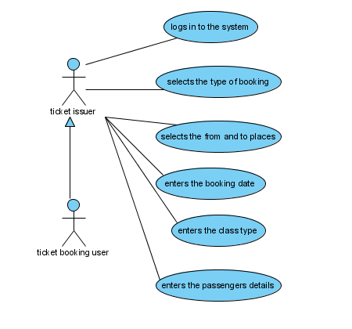
Figure:5.1

Class diagrams:

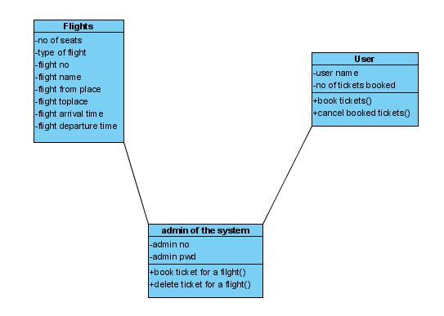
Figure:5.2

Class Diagram:

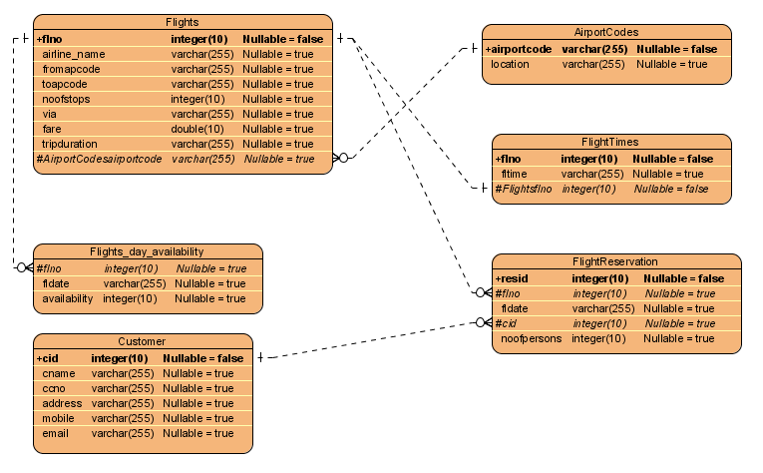

Figure: 5.3

